**How Semantic Segmentation or FCNs are used in Autonomous Vehicles**

**Summary**

Within the domain of steering a car with camera sensor data, FCNs can be used to determine a set of pixels which are classified as road pixels, and thus are often wont to directly understand if the network correctly perceived the road or not within a given input image. A FCNs output also offers a contour for the road’s shape given the classified road pixels, which are useful to positively calculate the direction of steering rather than inferring it through the dense layers of the neural network within the original solution. This exposes algorithmic solutions or others parameters to regulate how the car should drive means closer to an edge on a turn or closer to the road center. This helps to determine the road’s shape and thereby influence the steering angle.

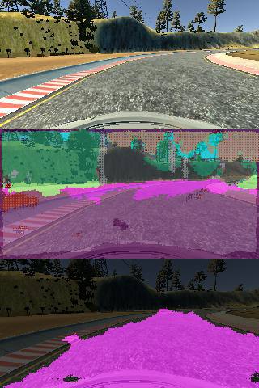

**Introduction**

A FCN is a network that does not contain any dense layer and classifies each pixel in the original image. The network is trained by providing an input image and label image. The label image has an equivalent size dimensions because the input image with each pixel identifying an object class that represents the corresponding pixel within the input image. FCNs are composed of two major stages, a encoding stage and a decoder stage.  this is accomplished with a combination of [1x1 convolutions](https://www.coursera.org/learn/convolutional-neural-networks/lecture/ZTb8x/networks-in-networks-and-1x1-convolutions)and [transposed convolutions](https://towardsdatascience.com/types-of-convolutions-in-deep-learning-717013397f4d), which multiplex and up-sample ConvNet output to the original size of the input image. Because of this down-sample followed by an up-sampling structure, they are referred to as[fully convolutional networks](https://people.eecs.berkeley.edu/~jonlong/long_shelhamer_fcn.pdf) (FCNs for short).

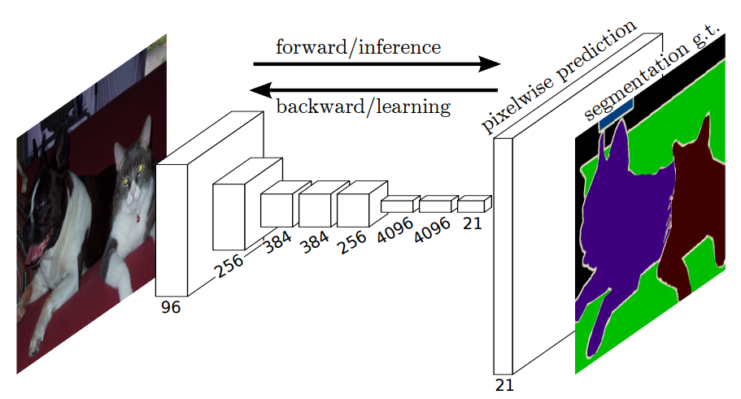

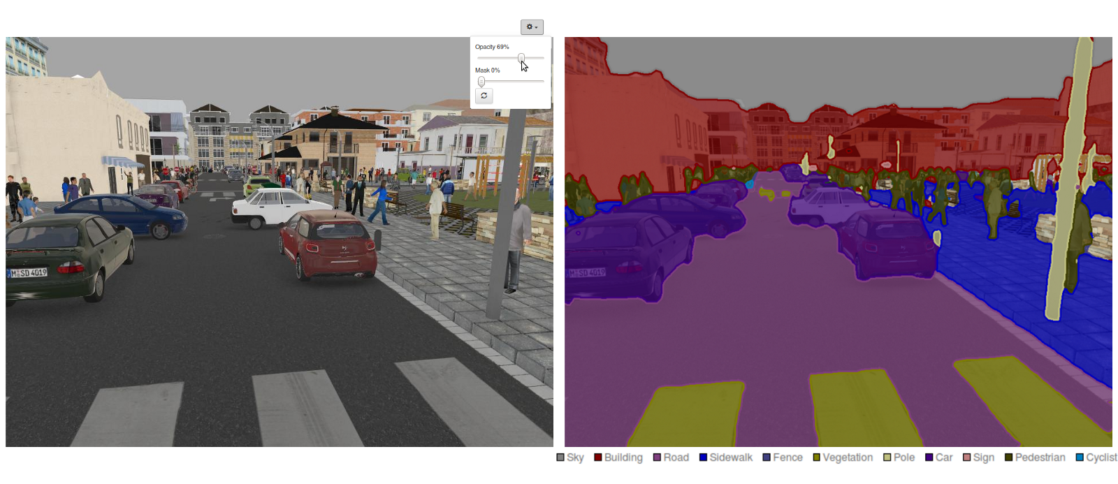

**Research**

ENet architecture is one of the fastest FCNs. The network was pretrained on CityScapes, a dataset that contains 5000 semantically segmented dash cam images and labels of city driving. The network offers 15+ FPS on a NVIDIA TX1 platform, along with good accuracy (81 mIOU) on CityScapes.

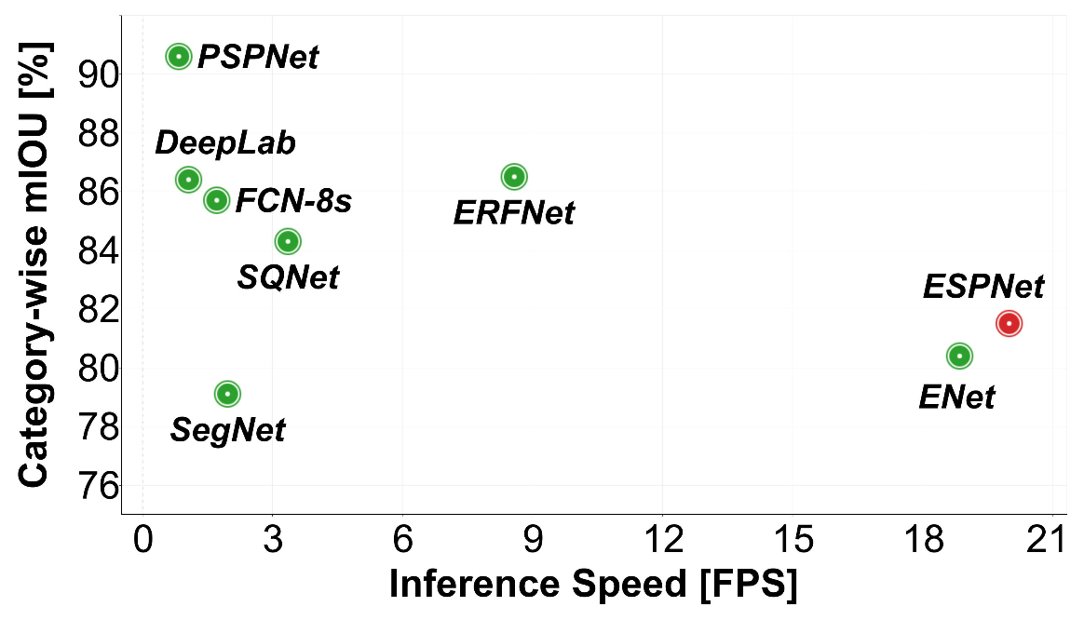

There are some challenges with FCN in determining the shape of road but it can be solved by providing a additional dense layer after the output of FCN instead of calculating the shape directly.

**PROOF OF CONCEPT**

Analysis of FCNs was done on the Car images . The biggest understanding from this process was that the body of most cars were getting segmented extremely well. The errors were mostly round the edges of the segmentation mask. These consisted of dark shadows near the wheels, cars painted an equivalent as background colour, really small antennas, roof racks etc. These are all things which might be difficult for a person's to differentiate also .So FCNs works nicely on car images and excellent tool for autonomous vehicles.

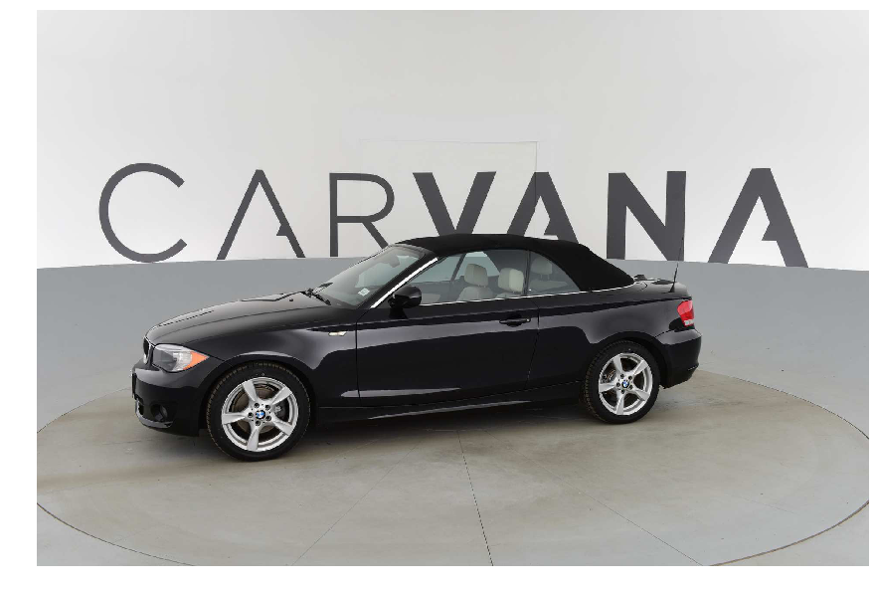

Input Image

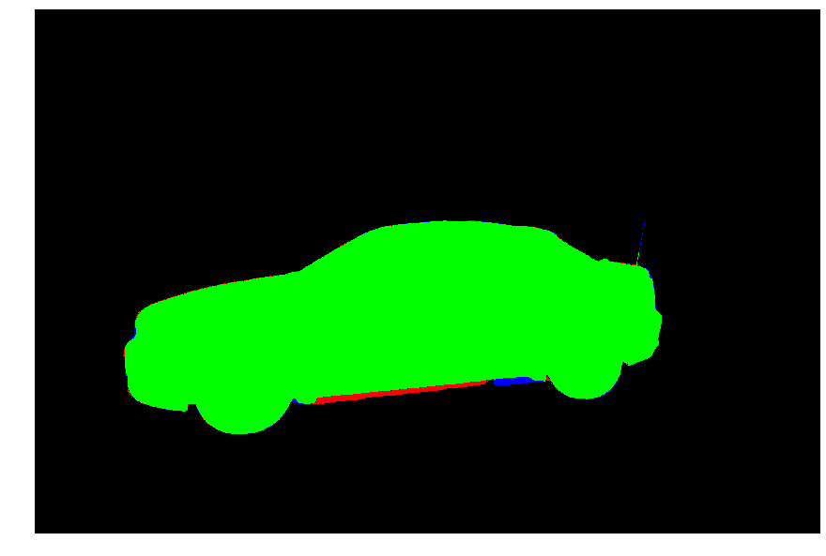

Result